**Project Report**

**Vendor Sales Analysis**

**By**

**Yash Vishwakarma**

**Project Report**

**Vendor Sales Analysis**

**By**

**Yash Vishwakarma**

**Business Problem**

The company partners with multiple liquor vendors to distribute products across regions. While overall sales volume and revenue are significant, profit margins vary widely among vendors and products. The management team faces challenges in:

1. Identifying top-performing vendors contributing the most profit.
2. Detecting underperforming vendors whose sales volumes are high but profit margins are low.
3. Optimizing purchase decisions by understanding the relationship between purchase cost, sales price, and total profit.
4. Identifying top vendors by sales contribution

**EDA Insights**

**a)**

*Certain vendors (e.g., DIAGEO North America Inc, Pernod Ricard USA) have high sales volumes but moderate margins, indicating potential over-reliance on volume.*

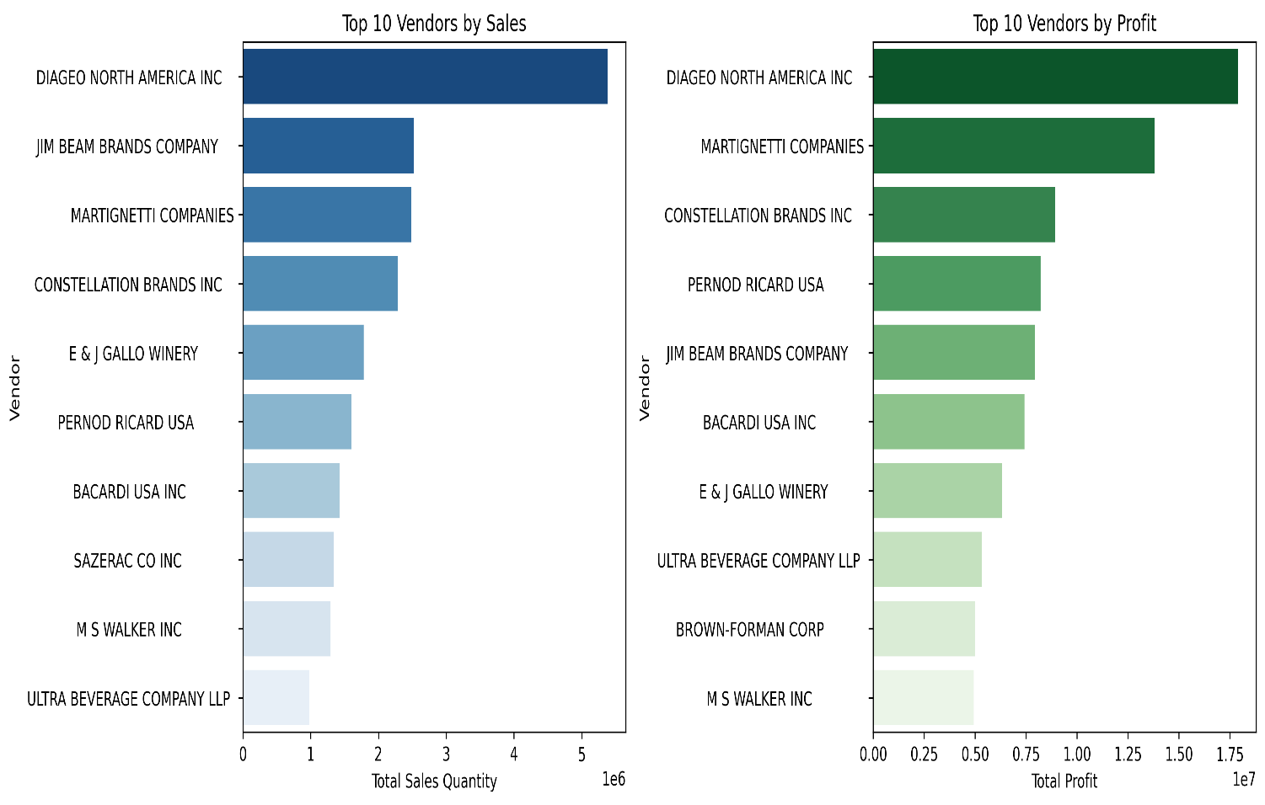

**b)**

*From the analysis of sales vs. profit, we observed that several vendors are generating* ***high sales revenue but relatively low profit margins****. This indicates that despite large sales volumes, the cost structure (purchase price, freight, or taxes) is eroding profitability.*

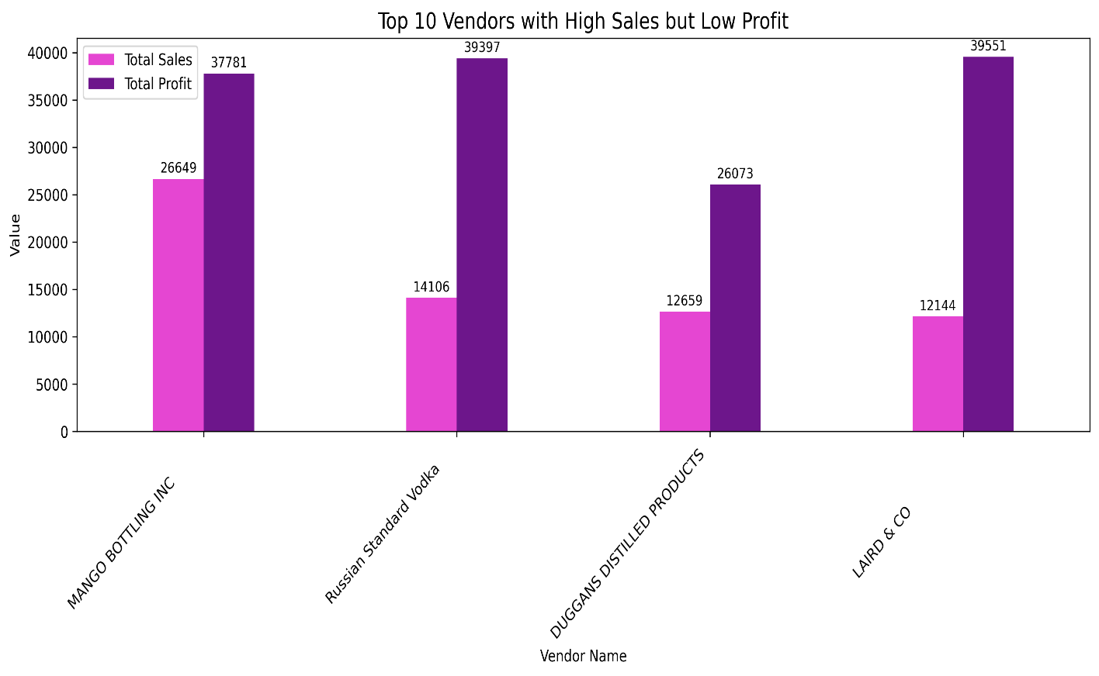

***Recommendation:*** *Vendors with* ***high sales but low profit margins*** *are likely focused on volume-based sales or competitive pricing. To improve profitability, the business should:*

* ***Review pricing strategies*** *to ensure that discounts or low margins are not eroding overall profit.*
* ***Negotiate better purchase costs*** *with these vendors, since the high sales volume gives the company stronger bargaining power.*
* ***Optimize product mix*** *by promoting higher-margin alternatives along with these high-volume items.*

*Whereas vice-versa is also present as there are some vendors generating* ***high profit with low sales****. This indicate that there is a possibility that they are selling premium products.*

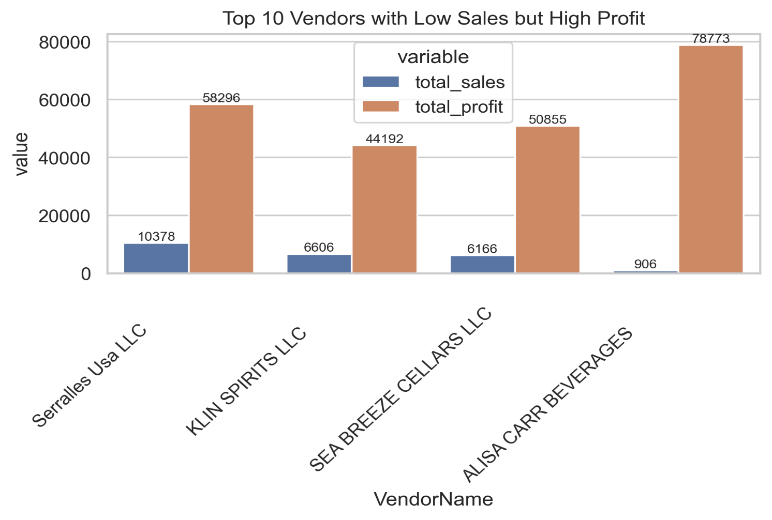

***Recommendation:****Vendors with high profit but low sales volume are likely selling premium or niche products. The business should not push these vendors for higher volumes in the same way as mass-market sellers. Instead, it should:*

* *Position these products as premium offerings to maintain exclusivity.*
* *Use targeted marketing to reach customers who value quality over price.*
* *Consider bundling premium items with popular products to boost overall sales without compromising margins.*

***c)***

*A box plot was created to categorize vendors into four groups based on their purchase cost (Low, Medium, High, Very High). The analysis revealed a clear pattern: as the purchase quantity increases, the unit purchase price tends to decrease. This indicates vendors who order in larger quantities can achieve lower unit costs, which directly improves their profit margins.*

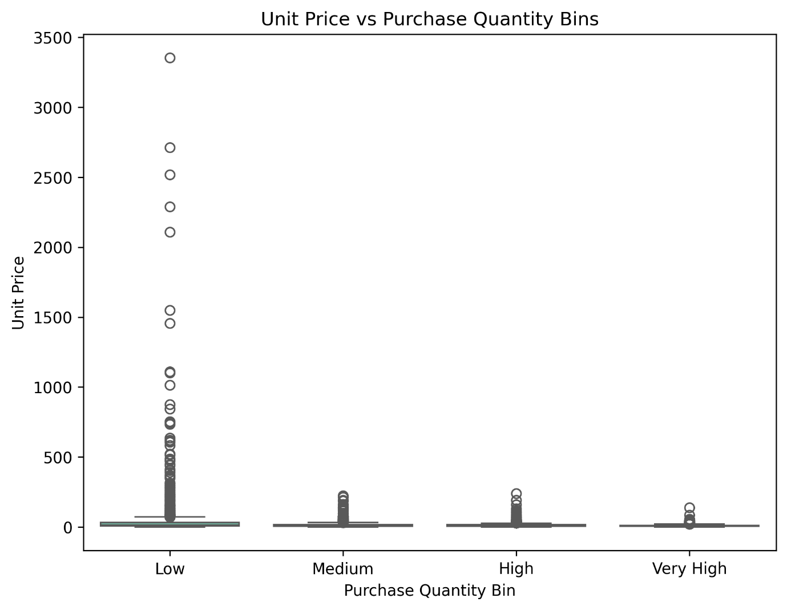

***Recommendation:*** *The business can optimize profitability by negotiating bulk purchases or consolidating orders with vendors that offer favourable pricing at higher quantities. This strategy helps lower costs per unit and maximizes profit while maintaining competitive sales pricing.*

***c)***

*A pie chart of the top 10 vendors by total sales was created. The analysis showed that a small group of vendors contributes a large share of overall sales, while the rest of the vendors have relatively minor contributions.*

